LECTURE 8
NETWORKING

TCP/IP Networking Overview
What is TCP/IP Networking?
- TCP/IP networking refers to the system of communication used by computers to connect and exchange data over networks, especially the internet.
- It is the most widely used networking protocol suite in the world.
Why TCP/IP is Important
- It forms the foundation of the Internet, meaning all internet communication relies on it.
- It allows billions of devices to communicate with each other reliably.
Scale of TCP/IP (from lecture data)
- Over 2.8 billion users were online worldwide (as per older data in lecture).
- Over 1 billion devices (hosts) were connected to the internet.
- This shows that TCP/IP is designed to handle very large-scale communication.
Key Idea
- TCP/IP is not a single protocol.
- It is a collection of protocols (protocol suite) that work together to manage communication.
What TCP/IP Handles
- Sending data from one device to another
- Breaking data into smaller parts (packets)
- Routing data through networks
- Delivering data to the correct destination

What is TCP/IP?
Full Form
- TCP: Transmission Control Protocol
- IP: Internet Protocol
Basic Working Concept
- TCP/IP divides responsibilities into two main parts:
  - IP handles addressing and routing
  - TCP handles reliable delivery
Simple Understanding
- IP decides where the data should go.
- TCP ensures the data reaches correctly and in order.
Role of IP (Internet Protocol)
- IP is responsible for:
  - Assigning addresses (IP addresses)
  - Sending packets from source to destination
- It is connectionless, meaning:
  - It does not establish a connection before sending data
  - It does not guarantee delivery
Role of TCP (Transmission Control Protocol)
- TCP ensures reliable communication between devices.
- It is connection-oriented, meaning:
  - A connection is established before data transfer begins
Features of TCP
- Ensures all data is delivered
- Maintains correct order of data
- Detects and corrects errors
- Retransmits lost data if necessary

TCP/IP (Detailed Working)
Packet-Based Communication
- Data is not sent as one large block.
- It is divided into smaller units called packets.
How Data Travels in TCP/IP
- The sender divides data into packets.
- Each packet contains:
  - Data
  - Source address
  - Destination address
- Packets travel through different routes in the network.
- At the destination:
  - Packets are reassembled into the original data.
Important Concept
- All internet communication uses IP for addressing.
- TCP or UDP is used on top of IP depending on the requirement.

Protocols
Definition of Protocol
- A protocol is a set of rules that defines how data is transmitted between devices in a network.
Why Protocols are Needed
- They ensure:
  - Proper communication
  - Correct data format
  - Error handling
- Without protocols, devices would not understand each other.
Main Protocols in TCP/IP
1. Internet Protocol (IP)
- Responsible for sending packets across networks.
- It is:
  - Connectionless
  - Unreliable (no guarantee of delivery)
- Its main job is routing data to the correct destination.
2. Transmission Control Protocol (TCP)
Nature
- Connection-oriented protocol
- Provides reliable communication
Key Features
- Guarantees delivery of data
- Maintains correct order of packets
- Performs error checking and correction
Congestion Control
- TCP monitors network traffic.
- If the network is busy, it reduces the speed of data transmission.
- If the network is free, it increases speed.
- This prevents network overload.
Flow Control
- TCP ensures that the sender does not send data faster than the receiver can handle.
- It balances the speed between sender and receiver.
3. User Datagram Protocol (UDP)
Nature
- Connectionless protocol
- Faster but less reliable
Key Characteristics
- Does not guarantee delivery
- Does not ensure order of packets
- No error correction mechanism
When UDP is Used
- When speed is more important than accuracy
- Examples include:
  - Video streaming
  - Online gaming
  - Voice calls

TCP/IP Network Stack
Definition
- The TCP/IP network stack is a layered structure used to organize how data is transmitted over a network.
- Each layer performs a specific function and passes data to the next layer.
Layers of TCP/IP Stack
1. Application Layer
- This is the top layer where user interaction happens.
- It provides services directly to applications.
Functions:
- Allows applications to send and receive data
- Acts as the interface between user and network
Examples:
- Web browsers
- Email clients
Working:
- When a user sends data, this layer starts the process and passes data to the transport layer.
2. Transport Layer
- Responsible for end-to-end communication between devices.
Functions:
- Breaks data into smaller units (segments)
- Adds headers for control information
- Ensures proper delivery (if using TCP)
Protocols used:
- TCP (reliable)
- UDP (fast but unreliable)
Working:
- Receives data from application layer
- Adds a header
- Sends it to the network layer
3. Network Layer
- Responsible for addressing and routing.
Functions:
- Adds source and destination IP addresses
- Determines the best path for data
Protocol:
- IP (Internet Protocol)
Working:
- Receives segments
- Converts them into packets (datagrams)
- Sends them to the correct destination
4. Data Link Layer (Link Layer)
- Handles communication within the same network.
Functions:
- Performs error checking
- Uses MAC (hardware) addresses
- Controls data transfer between devices on same network
Working:
- Receives packets
- Converts them into frames
- Passes them to physical layer
5. Physical Layer
- The lowest layer of the stack.
Functions:
- Transmits raw data as electrical signals or bits
- Handles physical connection (cables, hardware)
Examples:
- Ethernet cables
- Fiber optics
- Wi-Fi signals
Working:
- Sends and receives actual bits over the medium

Layers + Encapsulation
What is Encapsulation?
- Encapsulation is the process of adding headers at each layer as data moves down the network stack.
How Encapsulation Works
- Data starts at the application layer as a message.
- As it moves downward: Each layer adds its own header.
- At the receiving side: Headers are removed in reverse order (decapsulation).
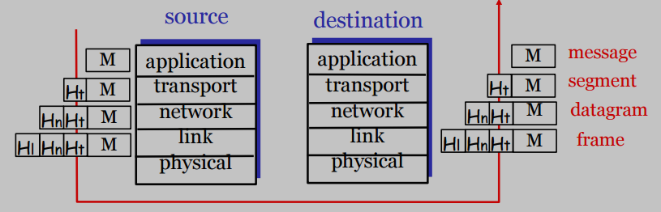
Data Transformation Across Layers
Layer | Data Name
Application | Message
Transport | Segment
Network | Datagram
Data Link | Frame
Physical | Bits
Example of Encapsulation
- Suppose an application sends 100 bytes of data:
Step-by-step addition:
- Transport layer (UDP) adds 8 bytes header
- Network layer (IP) adds 20 bytes header
- Data link layer (Ethernet) adds 18 bytes header
Final Result
- Original data becomes larger due to headers added at each layer.
Key Points to Remember
- Each layer has a specific role.
- Data is wrapped with headers at each layer.
- This wrapping process is called encapsulation.
- At the receiver, the process is reversed (decapsulation).
- Encapsulation ensures proper delivery, routing, and error handling.

Addressing in TCP/IP
Basic Idea
- Different layers in the TCP/IP model use different types of addresses.
- Each type of address serves a specific purpose in communication.
Types of Addressing by Layer
1. Application Layer Addressing
- This layer allows users to use hostnames instead of numeric addresses.
Examples:
- www.google.com
- www.example.com
Key Point
- Hostnames are human-friendly and easier to remember.
- These names are later converted into IP addresses using DNS.
2. Network Layer Addressing (IP Address)
- The network layer uses IP addresses to identify devices.
Characteristics
- Every device on a network must have a unique IP address.
- Used for routing data across networks.
Example:
- 192.168.1.1
3. Link Layer Addressing (MAC Address)
- The link layer uses MAC (Media Access Control) addresses.
Characteristics
- A MAC address is a hardware address assigned to a network interface.
- It is typically 48 bits long (for Ethernet).
Structure of MAC Address
- First 3 bytes: Manufacturer ID
- Last 3 bytes: Device-specific serial number
Example:
- 00:1A:2B:3C:4D:5E

Ports in Networking
What is a Port?
- A port identifies a specific process or service running on a device.
- It helps the system know which application should receive the data.
Key Points About Ports
- Ports are associated with applications or services.
- A single device can run multiple services using different ports.
Well-Known Ports
- A list of standard ports is stored in:
  - /etc/services
Examples:
- HTTP → Port 80
- HTTPS → Port 443
- FTP → Port 21
Privileged Ports
- Ports numbered 0 to 1024 are called privileged ports.
- These ports require administrator (root) permissions to use.

Address Types
Basic Idea
- At the IP and link layers, there are different ways to send data depending on the target.
1. Unicast
- Data is sent from one sender to one receiver.
Example
- Sending a message from your computer to a specific website server.
2. Broadcast
- Data is sent from one device to all devices in the network.
Key Feature
- All bits in the host part of the address are set to 1.
Example
- A message sent to all devices in a LAN.
3. Multicast
- Data is sent from one sender to a group of selected devices.
Key Feature
- Uses special IP address range:
  - 224 to 239 (IPv4)
Example
- Live video streaming to multiple users.
Broadcast
- Broadcast means sending data from one sender to all devices in a network.
- Every device on the network receives the data, whether it needs it or not.
Multicast
- Multicast means sending data from one sender to a selected group of devices.
- Only devices that are part of the group receive the data.

IP Addresses
What is an IP Address?
- An IP address is a unique identifier assigned to each device on a network.
- It is used to identify and locate devices for communication.
IPv4 Address Structure
- An IPv4 address consists of 4 bytes (32 bits).
- It is usually written in decimal format, separated by dots.
Example:
- 128.180.2.57
Network and Host Portions
- An IP address is divided into two parts:
  - Network portion → identifies the network
  - Host portion → identifies the device within that network
Classful Addressing (Old Method)
Originally, IP addresses were divided into classes:
Class | First Byte Range | Format | Usage
A | 1 – 126 | N.H.H.H | Very large networks
B | 128 – 191 | N.N.H.H | Large organizations
C | 192 – 223 | N.N.N.H | Small networks
D | 224 – 239 | Multicast | Group communication
E | 240 – 255 | Experimental | Not commonly used
Example
- IP Address: 128.180.2.57
  - Class: B (since 128–191 range)
  - Network part: 128.180
  - Host part: 2.57

Subnetting
What is Subnetting?
- Subnetting is the process of dividing a large network into smaller networks (subnets).
Why Subnetting is Needed
- Large networks are often too big to manage efficiently.
- Subnetting helps:
  - Improve network performance
  - Reduce congestion
  - Organize networks better
  - Use IP addresses efficiently
Key Concept
- Subnetting extends the network portion of an IP address into the host portion.
- This creates multiple smaller networks within a larger one.
Example from Lecture
- A Class B network like 128.180 has:
  - Total addresses: 65,534 hosts
Problem
- This is too large for practical use.
Solution
- Break it into smaller networks such as:
  - 128.180.5.*
  - 128.180.98.*
  - 128.180.14.*

Subnetting Example
Step 1: Original Network
- Network: 128.180 (Class B)
- Very large network
Step 2: Create Subnet
- Example subnet: 128.180.98
Step 3: Use Subnet Mask
- Subnet mask defines how much of the address is network vs host.
Example:
- 255.255.255.0
  - First 3 bytes → network
  - Last byte → host
CIDR Notation (Shortcut)
- Instead of writing subnet mask, we use CIDR notation.
Examples:
- 128.180.98.0/24
→ 24 bits for network
Breaking Further (Advanced Subnetting)
- Subnets can also be divided further:
Examples:
- 128.180.98.128/25
- 128.180.120.0/22
Meaning
- More bits are used for network
- Fewer bits remain for hosts

CIDR (Classless Inter-Domain Routing)
Definition
- CIDR is a method of IP addressing that removes the fixed class system (A, B, C).
- It allows networks to be defined using a prefix length, making addressing more flexible.
Key Features of CIDR
1. No Fixed Classes
- CIDR eliminates class-based addressing.
- Networks are no longer restricted to fixed sizes like Class A, B, or C.
2. Uses Prefix Length (/n)
- CIDR uses a length field to define the network portion.
Example:
- 128.180.0.0/16
  - First 16 bits → network
  - Remaining bits → host
3. Flexible Allocation
- IP addresses can be allocated based on actual need, not fixed class sizes.
- This avoids wastage of IP addresses.
4. Aggregation (Supernetting)
- Multiple smaller networks can be combined into a larger network.
Example:
- 192.200.254.0
- 192.200.255.0
Combined as:
- 192.200.254.0/23
5. Supports Efficient Routing
- Aggregated networks reduce the number of entries in routing tables.
- This improves router performance and scalability.
CIDR Notation Details
Format
- Written as:
  - IP address / n
Where:
- n = number of bits used for network
Important Formulas and Concepts
1. Number of Addresses
- Total addresses in a CIDR block:
  - 2^(32 − n)
Where n = prefix length
2. Network Address (First Address)
- Found by:
  - Performing bitwise AND between IP address and subnet mask
Formula:
- First address = (any IP) AND (network mask)
3. Last Address (Broadcast Address)
- Found by:
  - Performing OR operation with inverted mask
Formula:
- Last address = (any IP) OR [NOT (network mask)]
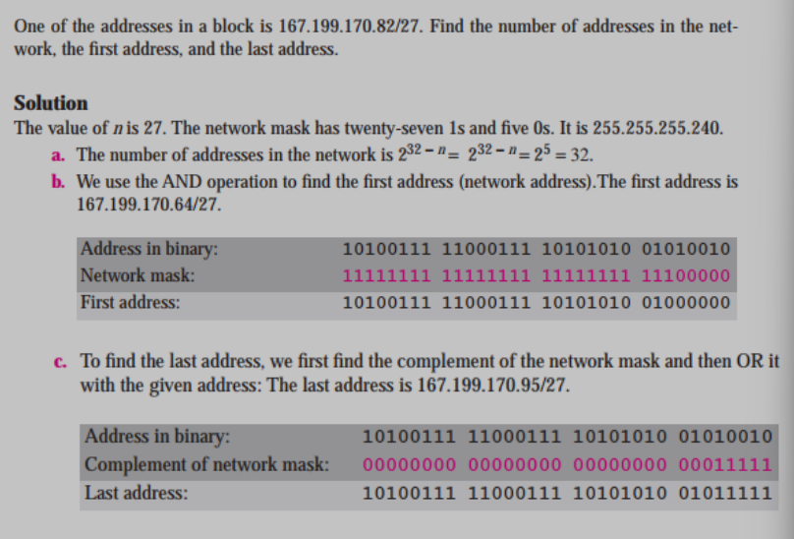
Advantages of CIDR
- Reduces wastage of IP addresses
- Allows flexible subnet sizes
- Supports aggregation of networks
- Reduces routing table size
- Improves overall network efficiency

NAT (Network Address Translation)
Definition
- NAT is a technique where a router modifies IP addresses and port numbers in packets.
- It allows internal (private) network devices to communicate with external networks using a public IP address.
How NAT Works
- When a packet leaves a private network:
  - The router intercepts the packet
  - Replaces:
    - Internal IP address → Public IP address
    - Internal port → External port
- When a response comes back:
  - The router uses a mapping table
  - It forwards the packet to the correct internal device
Key Features
- Maintains a mapping (translation table):
  - Ensures incoming packets are delivered to the correct internal host
- Typically:
  - Uses one public IP address
  - Uses multiple port numbers to handle many devices
- Can (in theory):
  - Map multiple hosts and ports in flexible ways
- Built into:
  - Most routers (including low-cost/home routers)
  - Operating systems like Linux
Important Understanding
- NAT allows many devices to:
  - Share a single public IP
- This helps reduce the demand for public IP addresses

Private Addresses
Basic Idea
- Private IP addresses are used inside internal networks.
- They are not routable on the internet (cannot be accessed directly from outside).
Why Private Addresses are Used
- NAT hides internal addresses, but:
  - It is not perfect
  - Some applications may include IP addresses inside data
- There can be conflicts:
  - Same IP address used internally and externally
- Solution:
  - Use private address ranges that are reserved and not used on the public internet
Private IP Address Ranges
Class A
- Range: 10.0.0.0 to 10.255.255.255
- CIDR: 10.0.0.0/8
Class B
- Range: 172.16.0.0 to 172.31.255.255
- CIDR: 172.16.0.0/12
Class C
- Range: 192.168.0.0 to 192.168.255.255
- CIDR: 192.168.0.0/16
Key Characteristics
- Not accessible from the internet
- Used in:
  - Home networks
  - Office networks
- Must use NAT to communicate with external networks

ARP (Address Resolution Protocol)
Definition
- ARP is a protocol used to find the MAC (hardware) address of a device when its IP address is known.
- It is used within a local network (LAN).
Why ARP is Needed
- Communication at different layers uses different addresses:
  - Network layer → IP address
  - Link layer → MAC address
- Problem:
  - Devices know the IP address of the destination
  - But actual delivery requires the MAC address
- Solution:
  - ARP is used to convert IP address into MAC address
How ARP Works
Step-by-Step Process
- A device wants to send data to another device on the same network.
- It knows the IP address of the destination but not the MAC address.
- It sends an ARP request (broadcast):
  - Message: “Who has this IP address?”
  - Sent to all devices in the network
- The device that owns that IP address responds with an ARP reply (unicast):
  - Sends its MAC address directly to the requester
Important Concepts
Broadcast Request
- ARP request is sent as a broadcast
- All devices receive it
Unicast Reply
- Only the correct device replies
- Reply is sent directly (unicast)
ARP Cache
- Once the MAC address is found:
  - It is stored in a table (ARP cache)
Why caching is used
- Avoids repeating ARP requests
- Improves performance
Additional Note
- ARP entries can also be learned through snooping (observing network traffic)
Key Points to Remember
- ARP maps:
  - IP address → MAC address
- Works only in local networks (LAN)
- Uses:
  - Broadcast for request
  - Unicast for reply
- Results are stored in a cache for faster future access
Simple Example
- Device A wants to send data to IP: 192.168.1.5
- It does not know MAC address
Process:
- Broadcast: “Who has 192.168.1.5?”
- Device B replies: “I have it, here is my MAC address”
- Device A stores it and sends data
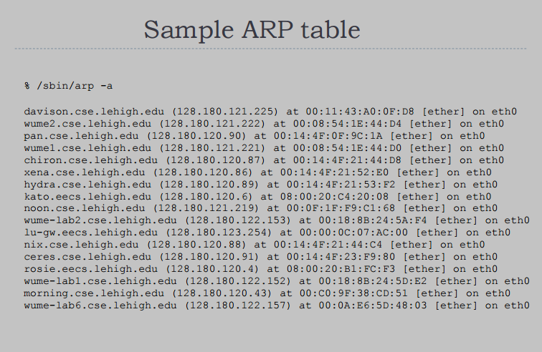

Network Configuration
Definition
- Network configuration refers to the process of setting up a computer so it can communicate on a network.
Steps to Set Up a System on a Network
1. Assigning an IP Address
- Each device must have a unique IP address.
- This identifies the device on the network.
Ways to assign:
- Manually (static IP)
- Automatically using DHCP
2. Setting Hostname
- A hostname is a human-readable name given to a device.
Example:
- server1
- laptop01
Purpose
- Easier to identify devices instead of remembering IP addresses.
3. Setting Default Gateway
- The default gateway is the router’s IP address.
- It is used when sending data outside the local network.
Key Idea
- If the destination is not in the same network:
  - Data is sent to the default gateway
4. DNS Configuration
- DNS (Domain Name System) is used to convert hostnames into IP addresses.
What needs to be configured
- IP address of DNS server
Example
- When you type a website name:
  - DNS converts it into an IP address
Configuration Files (Linux-Based Systems)
Important File
- /etc/sysconfig/network-scripts/ifcfg-eth0
Contains:
- IP address
- Netmask
- Broadcast address
- Gateway
Key Points
- Network configuration is required for any system to communicate.
- It includes:
  - IP address
  - Hostname
  - Gateway
  - DNS
- Can be done manually or automatically (via DHCP)

Mapping Names to IP Addresses
Definition
- Mapping names to IP addresses means converting a hostname into its corresponding IP address.
Why It is Needed
- Humans prefer names (like websites).
- Computers communicate using IP addresses.
- So, conversion is required.
Methods of Name Resolution
1. /etc/hosts (Local File)
Description
- A simple file that stores manual mappings of hostname to IP.
Example Entry
- 127.0.0.1 localhost
- 192.168.1.10 server1
Characteristics
- Stored locally on the system
- Used when:
  - DNS is not available
  - During system startup
Advantages
- Fast (no network needed)
Disadvantages
- Not scalable for large networks
2. DNS (Domain Name System)
Definition
- DNS is a system used to convert human-readable names (hostnames) into IP addresses.
Why DNS is Needed
- Humans prefer names like:
  - www.google.com
- Computers use IP addresses like:
  - 142.250.183.14
- DNS acts as a translator between names and IP addresses.
How DNS Works
- User enters a hostname (e.g., www.example.com)
- The system sends a request to a DNS server
- DNS server looks up the IP address
- DNS server returns the IP address
- The system connects to that IP address
Advantages
- Easy to use (no need to remember IPs)
- Works globally
- Efficient and scalable
Example
- Input: www.google.com
- Output: Corresponding IP address
3. NIS (Network Information Service)
Definition
- NIS is a system used to share configuration data across multiple computers in a network.
Why NIS is Used
- In large organizations, many systems need the same data:
  - User accounts
  - Passwords
  - Hostnames
- Instead of storing this data on every machine:
  - It is stored on a central NIS server
How NIS Works
- A client system needs some information (e.g., user login)
- It sends a request to the NIS server
- The server provides the required data
- The client uses that data
Types of Data in NIS
- Usernames and passwords
- Hostnames
- Network configuration data

DHCP (Dynamic Host Configuration Protocol)
Definition
- DHCP is a protocol used to automatically assign network configuration to devices.
- Instead of manual setup, devices get settings from a DHCP server.
Key Concept: Lease
- A device does not get an IP permanently.
- It leases (borrows) network configuration for a limited time.
What DHCP Provides
A DHCP server can automatically assign:
- IP address
- Subnet mask
- Default gateway (route to internet)
- DNS server addresses
- Other configurations like:
  - Syslog servers
  - NTP (time servers)
  - Proxy servers
Why DHCP is Important
- Eliminates manual configuration
- Reduces errors
- Makes network management easier
- Used in almost all modern networks

How DHCP Works
Step-by-Step Process (High Level)
1. Client Request (Broadcast)
- When a device connects to a network:
  - It does not have an IP address
  - It sends a broadcast message:
    - “Who am I?” (request for configuration)
2. Server Response
- DHCP server replies with:
  - Available IP address
  - Network configuration details
3. Lease Assignment
- The client accepts the configuration
- The IP is leased for a specific time period
4. Lease Renewal
- When half of the lease time is over:
  - The client requests to renew the lease
- This ensures continuous connectivity
5. Server Responsibility
- DHCP server must:
  - Track all leased IP addresses
  - Maintain records even after reboot

ifconfig
Definition
- ifconfig is a command used to configure and view network interface settings.
What it is used for
- Assign or change IP address
- Set subnet mask
- Enable or disable a network interface
- View network details such as:
  - IP address
  - MAC address
  - Network status
Example
- ifconfig eth0 → shows details of interface
- ifconfig eth0 up → enables interface
- ifconfig eth0 down → disables interface

CentOS/RHEL Configuration Files
Purpose
- These files are used to store network configuration permanently in Linux systems.
Important Files
1. /etc/sysconfig/network
- Stores:
  - System hostname
  - Default gateway
2. /etc/sysconfig/network-scripts/ifcfg-*
- Used for individual network interfaces (e.g., eth0, eth1)
Contains:
- IP address
- Netmask
- Gateway
- Boot settings
3. Static Routes Files
- Used to define manual routing paths
- Helps control how data moves between networks

